CMSC 678 Project 3
Paul Hudgins
Department of Computer Science
Virginia Commonwealth University
Richmond, VA, USA

Abstract—This report details the author's methods and results for CMSC 678 Project 3. A two-layer neural network was evaluated using a single split of a cancer data set. Performance comparisons were made for the number of iterations and number of hidden layer neurons.
Keywords-Neural network, Matlab,

Running the Project
Code for Part 1 can be executed by running hudgins_project3.m. A total of 28 training periods will be executed, so execution may take several minutes.

Methods

Neural Network Design
A two-layer neural network was developed in Matlab based on the methods described in [1]. Hyperbolic tangent was used as the activation function for hidden layer neurons. After experimentation, a learning rate of 0.02 was used.

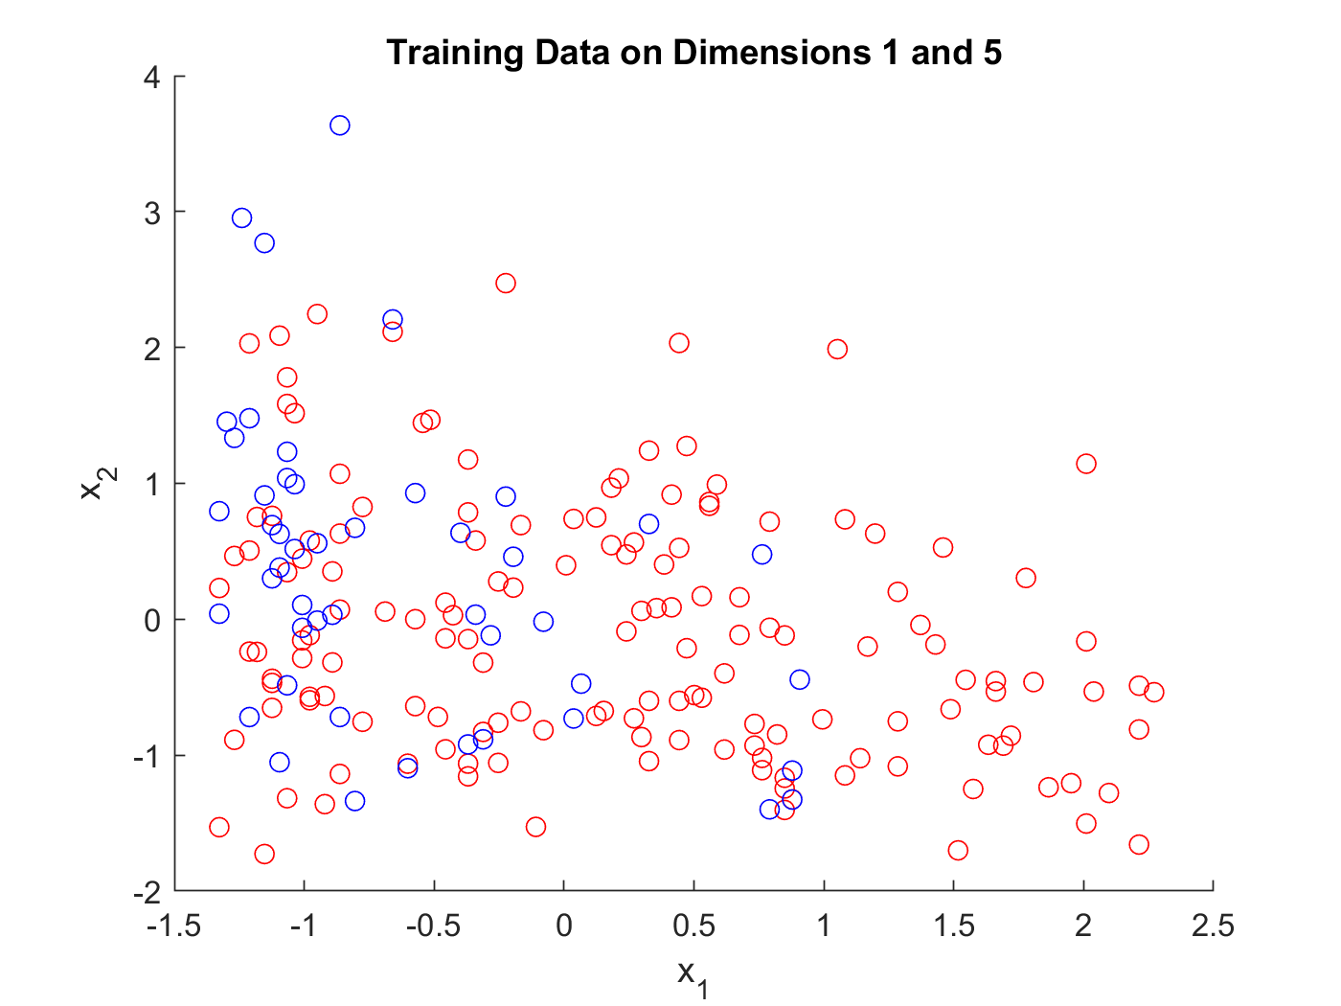

- Training data on two dimensions.

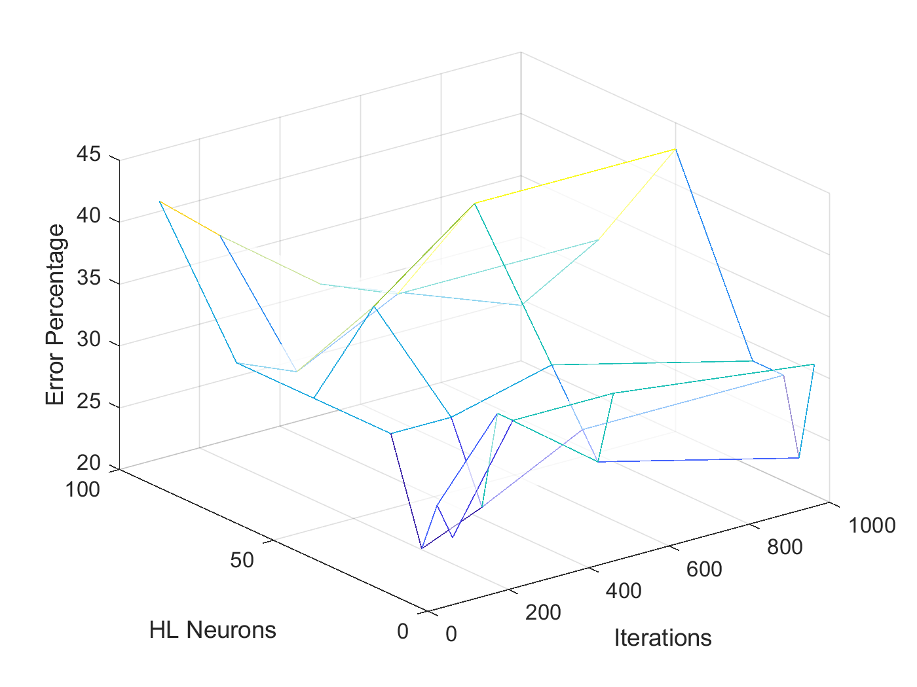
- Errors for training and epochs.

Dataset and Experimental Setup
Training data consisted 198 examples of two-dimensional cancer-related data, divided into two classes. Training data is not linearly separable. A two-dimensional projection of this data is shown in Figure 2. Neural networks were evaluated on a 75-25 split of this data. Evaluation was performed for four different numbers of iterations: 100, 250, 500, and 1000. For each of these, evaluations were performed for the following numbers of hidden neurons: 5, 10, 15, 25, 50, 75, 100.

Results
Comparison of performance for numbers of hidden neurons and iterations is provided in Figure 2. The lowest error percentage achieved was E = 22.45% for N = 15 and I = 100. The lowest error achieved for class 1 was 2.86% and the lowest error achieved for class 2 was 35.71%.

References
- V. Kecman, 'Multilayer Perceptron ie Neural Network', Virginia Commonwealth University, 2018

I

